Consortium on Insulation Life in Emerging Environments
(COIL)
Designing and operating electrical insulation systems for the next 50 years

Purpose
Decades of experience have led to robust methods of predicting insulation life under 50/60 Hz ac and the transients that occur in those systems. However, nowadays ac modulated voltage (that is, ac obtained by power electronics inverters) and dc voltage are making significant inroads in both the utility grid and in electrified transportation, which is introducing different failure mechanisms, making it challenging to design, specify, assess heath and devise Condition-Based Monitoring plans in new ac and dc systems.
The goal of this research consortium is to permit industry and government agencies to jointly fund research that provides critical information needed to predict life, design insulation systems and monitor their health in components of such innovative electrical assets. Using the knowledge developed and the results of ongoing research projects at CAPS-FSU, participants can develop their proprietary materials, insulation systems, specifications and testing procedures.

Technical Introduction
Failure in electrical systems is typically caused by a combination of thermal, electrical, mechanical, and chemical factors and often presents as electrical insulation failure. Under ac, the incipient failure is frequently spotted out by the inception of extrinsic aging mechanisms, as partial discharges. Aging rate and reliability can be drastically affected by extrinsic aging factors,
This situation is shown graphically in this figure. The life (L) is the time (t) that the insulation can be expected to withstand the design electric field (E). For organic insulation materials, if extrinsic aging mechanisms as partial discharges (PD) are active, the system life can be very short. PD can incept single the beginning of operation, or during life, by the presence of defects or growth of defects caused by e.g. thermal and electrical mechanical aging.
log (E)

This insight gained from ac experience that is expected to be valid under power electronics and dc voltage supply.
log (tPD) log (L)

There are two important factors shaping the need for better data under modulated as and dc voltage. One factor is that, globally, the voltage levels at which designers would like to operate new ac and dc systems, especially in transportation electrification, are increasing well beyond the limited performance data that exists. Increasing voltage while maintaining reliability requires more engineering data. The second factor is the role of power electronics. Power electronics use higher switching speed, frequency and voltage operation, and higher temperature operation than were previously possible. Also, power density much be as high as possible, which implies high design electric fields. This can induce accelerated ageing across the entire voltage range, likely going down to a few hundred volts, thus becoming a concern in application that never experienced before such problems, as aircraft and electric cars. This effect can reduce life in cables, motors, generators, transformers and even the power electronics packages and circuits themselves

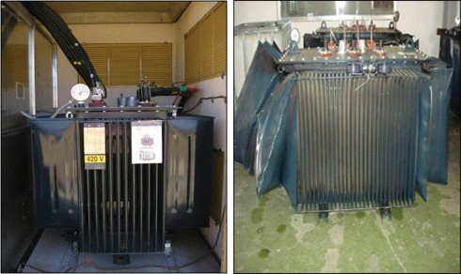
The issue is the pulsed waveforms that can be produced with very rapid rise and fall times. The difference between the partial discharge activity with inverter waveforms and a 60 Hz sinusoidal system are shown in this figure. The figure shows the partial discharge patterns when the voltage is produced by a two-level inverter, a five-level inverter and a sine wave. It is clear that the inverter waveform is producing quite different patterns. This research will focus on the linkage of the various behaviors to insulation life.

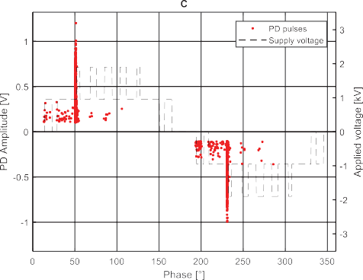
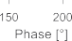
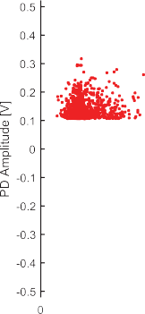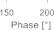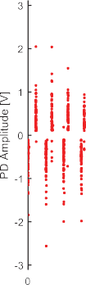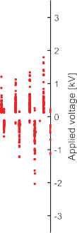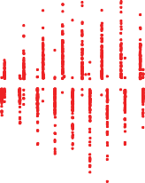Organization
The Center for Advanced Power Systems at Florida State University will manage the consortium. The University researchers leading the activity will be Dr. Gian Carlo Montanari, who will lead the technical activities, and Dr. Roger McGinnis, who will provide programmatic oversight. Both Dr. Montanari and Dr. McGinnis have decades of experience in insulation research.
The research will be funded by membership fees. The annual fee is $50,000 per participant. Companies that want to provide greater support and exert greater influence on the research direction can purchase more than one membership. Companies that join after the first year of operation may also be required to pay a one-time entrance fee set by the participants to compensate for start-up costs.
All of the research will be shared by the participants and is expected to eventually be published. All participants will receive a non-exclusive royalty free worldwide license for all intellectual property developed. The University maintains the right to continue practicing and expanding upon any Consortium intellectual property.
The research priorities are proposed by the researchers and selected by the participants. For voting, the University has two votes. It is anticipated the prioritization will be a result consensus and com- promise.
The participants will have, via semiannual meetings and intermediate reports, first access to the information produced. Moreover, they will guide the research direction. In that respect, the semiannual meetings are expected to provide continuous insight into the state of the art in this field. As students will be involved in the research, the participants will have an opportunity to meet students who have important skills for their companies. So, the consortium may also serve as a useful recruiting tool.
Although the research results are shared among the participants in the consortium, there may be a benefit for a participant to negotiate an additional separate project with the university for which the results would not be shared with the consortium. This is a logical and expected follow up of the Consortium.

